**CRM SALES DATA OVERVIEW**

* This project utilizes four interconnected tables to analyze sales performance, product adoption and account development trends.
* The account table contains key information about customer companies. The field name account was unique.
* identifier for the account (PRIMARY KEY).
* Products table contains details of the product offered by the company where the product field was the specific product name (PRIMARY KEY).
* Sales team table maps sales agents to their managers and operational regions where saleagent field represents the ID of the sales agent responsible for the deals(PRIMARY KEY).
* Sales pipeline table captures all sales activities, opportunities and closed deals where opportunity id was the unique identifier for each sales opportunity (PRIMARY KEY), sales agent (FOREIGN KEY), products (FOREIGN KEY) and account (FOREIGN KEY).

**Purpose of this project:**

* Analyze sales funnel performance by managers, sales agents and sector.
* Identify high value accounts, products and sectors contributing to the most revenue.
* Track sales pipeline over time(lost opportunity, monthly rates).
* Pinpoint underperforming areas (accounts, managers, agents).

**TABLE INFORMATION:**

**SELECT * FROM ACCOUNTS;**

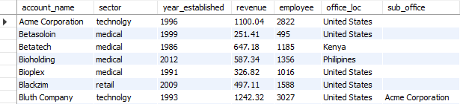

**SELECT * FROM PRODUCTS;**

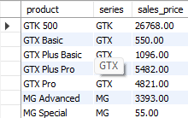

**SELECT * FROM SALES_PIPELINE;**

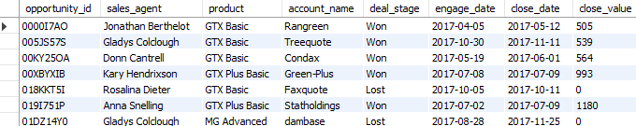

**SELECT * FROM SALES_TEAM;**

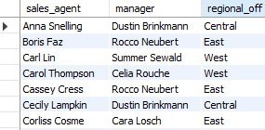

**QUESTION: WHICH ACCOUNTS HAVE AT LEAST WON ONE DEAL, AND WHAT IS THE TOTAL REVENUE FROM THEM?**

**GOAL: IDENTIFY VALUABLE CUSTOMERS CONTRIBUTING TO THE COMPANY REVENUE.**

Query:

SELECT ACCOUNT_NAME, SUM(CLOSE_VALUE) AS TOTAL_REVENUE

FROM sales_pipeline

WHERE deal_stage = "Won"

GROUP BY ACCOUNT_NAME

ORDER BY TOTAL_REVENUE DESC;

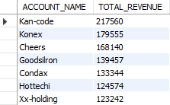

ANALYSIS: For accounts for Kan-code, konex;we need to focus on retention efforts and loyalty

programs for these accounts since these accounts generating the top revenue

**QUESTION: HOW MANY TOTAL WON DEALS AND LOST DEALS ARE RECORDED PER SALES AGENT?**

**GOAL: EVALUATE BASIC PERFORMANCE OF EACH SALES AGENT.**

SELECT SALES_AGENT, COUNT(*) AS TOTAL_DEALS,

SUM(CASE WHEN DEAL_STAGE = 'WON' THEN 1 ELSE 0 END) AS WON_DEALS,

SUM(CASE WHEN DEAL_STAGE = 'LOST' THEN 1 ELSE 0 END) AS LOST_DEALS

FROM SALES_PIPELINE

GROUP BY SALES_AGENT

ORDER BY WON_DEALS DESC;

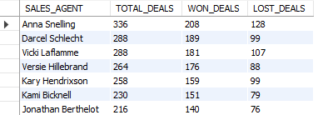

Analysis: This query identifies agents with a high volume of deals,lost deals and the won deals. Anna Snelling has the high volume of deals with the highest winning rate

**QUESTION: WHO ARE THE TOP RANKED SALES AGENTS BASED ON CLOSED DEALS WITHIN EACH OFFICE LOCATION?**

**GOAL: RECOGNIZE TOP REGIONAL PERFORMERS AND STIMULATE COMPETITION ACROSS OFFICES.**

SELECT SP.SALES_AGENT, A.OFFICE_LOC, SUM(SP.CLOSE_VALUE) AS TOTAL_CLOSE_DEALS,

DENSE_RANK() OVER(PARTITION BY A.OFFICE_LOC ORDER BY SUM(SP.CLOSE_VALUE) DESC) AS AGENT_RANK

FROM SALES_PIPELINE SP

INNER JOIN ACCOUNTS A ON SP.ACCOUNT_NAME = A.ACCOUNT_NAME

GROUP BY SP.SALES_AGENT, A.OFFICE_LOC;

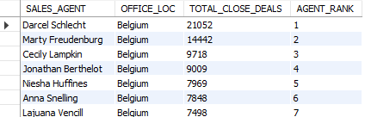

Analysis:This query identifies high performing sales agents based on their regional office, for example Darcel is the top performer for the USA/Belgium region with the most closed deals. Regions constantly dominated by one or two agents might suggest an over reliance; succession planning is needed.

**QUESTION: WHAT ARE THE TOP SELLING PRODUCTS BY SERIES BASED ON TOTAL SALES PRICE?**

**GOAL: IDENTIFY LEADING PRODUCTS TO OPTIMIZE STOCK AND PROMOTION.**

WITH TOP_PRODUCT AS

( SELECT PRODUCT, SERIES, SUM(SALES_PRICE) AS TOTAL_PRICE,

DENSE_RANK() OVER(PARTITION BY SERIES ORDER BY SUM(SALES_PRICE) DESC) AS TOP_RANK

FROM PRODUCTS

GROUP BY PRODUCT, SERIES)

select * FROM TOP_PRODUCT

WHERE TOP_RANK = 1;

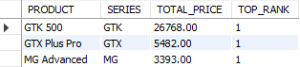

The top product here is **GTK 500** and it should be prioritized for marketing, cross selling

and inventory planning while under forming series may need promotional discounts

**QUESTION: HOW LONG DOES IT TAKE ON AVG TO CLOSE A DEAL IN EACH SECTOR?**

**GOAL: BENCHMARK SECTOR SPECIFIC SALE CYCLE TO OPTIMIZE RESOURCE ALLOCATION, FORECAST REVENUE AND SET REALISTIC SALES TARGETS.**

SELECT A.SECTOR, ROUND(AVG(DATEDIFF(SP.CLOSE_DATE, SP.ENGAGE_DATE))) AS AVERAGE_NO_DAYS

FROM SALES_PIPELINE SP

INNER JOIN ACCOUNTS A ON SP.ACCOUNT_NAME = A.ACCOUNT_NAME

WHERE SP.DEAL_STAGE = "WON"

GROUP BY A.SECTOR

ORDER BY AVERAGE_NO_DAYS DESC;

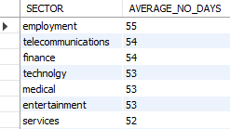

Analysis: Sectors with longer close time like employment and telecommunications may require longer nurturing and following campaigns. Knowing closed times can improve expected revenue timelines

**QUESTION: WHAT IS THE MOST RECENT DEAL FOR EACH ACCOUNT**

**GOAL:TO MAINTAIN CLIENT ENGAGEMENT AND IDENTIFY NEW RE-ENGAGEMENT OPPORTUNITIES**

WITH MOST_RECENT_DEAL AS

(SELECT ACCOUNT_NAME, CLOSE_VALUE, DEAL_STAGE, CLOSE_DATE,

DENSE_RANK() OVER(partition by ACCOUNT_NAME ORDER BY CLOSE_DATE DESC) AS RECENT_DEAL

FROM SALES_PIPELINE)

SELECT ACCOUNT_NAME, CLOSE_VALUE, DEAL_STAGE, CLOSE_DATE

FROM MOST_RECENT_DEAL

WHERE RECENT_DEAL = 1;

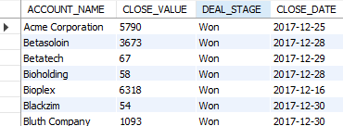

Analysis: Orders without recent deals maybe at churn risk - trigger a reactivation campaign and recent wins like acme corporation signal leads for product pitches.

**QUESTION: HOW HAS EACH SALES AGENT REVENUE CHANGED OVER TIME**

**GOAL: TRACK REVENUE GROWTH/DECLINE PER SALES AGENT TO SPOT THE TRENDS EARLY**

WITH SALES_REVENUE AS

(SELECT SALES_AGENT, CLOSE_DATE, SUM(CLOSE_VALUE) AS CURRENT_REVENUE,

LAG(SUM(CLOSE_VALUE)) OVER (partition by SALES_AGENT ORDER BY (CLOSE_DATE)) AS PREVIOUS_REVENUE

FROM SALES_PIPELINE

GROUP BY SALES_AGENT,CLOSE_DATE)

SELECT SALES_AGENT, CLOSE_DATE, CURRENT_REVENUE - coalesce(PREVIOUS_REVENUE,0) AS REVENUE_DIFFERENCE

FROM SALES_REVENUE;

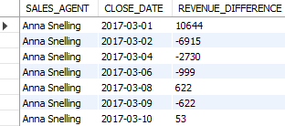

Analysis: Agents showing continuous growth can be strong candidates for leadership roles while declining candidates might indicate loss of key accounts.

**QUESTION: WHAT IS EACH ACCOUNTS WIN RATE AND WHICH ACCOUNTS HAVE A WIN RATE BELOW 60%**

**GOAL: IDENTIFY UNDERPERFORMING ACCOUNTS BASED ON DERIVED WIN RATE METRICS**

WITH ACCOUNT_DEAL AS

(SELECT ACCOUNT_NAME, COUNT(DEAL_STAGE) AS TOTAL_DEALS,

SUM(CASE WHEN DEAL_STAGE = 'WON' THEN 1 ELSE 0 END) AS WON_DEALS

FROM SALES_PIPELINE

GROUP BY ACCOUNT_NAME)

SELECT ACCOUNT_NAME, ROUND(WON_DEALS/TOTAL_DEALS,2) AS WIN_RATE

FROM ACCOUNT_DEAL

WHERE WON_DEALS/TOTAL_DEALS < 0.60;

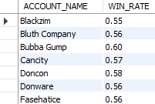

Analysis: This insight surfaces accounts like blackzim, bluth company are engaging in multiple deals but failing to convert most of them. These accounts need a deeper investigation

**QUESTION: WHAT IS MONTHLY TREND OF TOTAL DEALS,WON DEALS AND LOSS DEALS?**

**GOAL: UNDERSTAND THE SALES PERFORMANCE OVER TIME TO IDENTIFY SEASONALITY OR MOMENTUM SHIFTS.**

SELECT DATE_FORMAT(CLOSE_DATE, '%Y-%m') AS MONTHS

FROM SALES_PIPELINE;

SELECT DATE_FORMAT(CLOSE_DATE, '%Y-%m') AS MONTHS, COUNT(DEAL_STAGE) AS TOTAL_DEALS,

SUM(CASE WHEN DEAL_STAGE = 'WON' THEN 1 ELSE 0 END) AS WON_DEALS,

SUM(CASE WHEN DEAL_STAGE = 'LOST' THEN 1 ELSE 0 END) AS LOST_DEALS

FROM SALES_PIPELINE

GROUP BY DATE_FORMAT(CLOSE_DATE,'%Y-%m')

ORDER BY MONTHS;

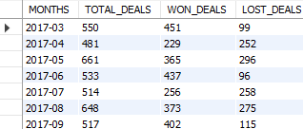

Analysis: Monthly tracking of deal outcomes enables trend detection and forecasting. a spike in losses or dip in wins in certain months can highlight poor campaign timings or product market misfit

**QUESTION: WHICH ACCOUNT HAVE BOTH LOST DEALS AND HAVE SHOWN AN INCREASE IN DEAL VALUE OVER TIME AND WHICH SECTOR DO THEY BELONG TO**

**GOAL: IDENTIFY DETECT UNDERPERFORMING ACCOUNTS DESPITE LOSSES ARE INCREASING IN PURCHASE VALUE, SIGNALING POTENTIAL FOR RECOVERY**

WITH LOST_DEALS AS

(SELECT SP.ACCOUNT_NAME, SP.DEAL_STAGE AS DEAL_STATUS, A.SECTOR

FROM SALES_PIPELINE SP

INNER JOIN ACCOUNTS A ON SP.ACCOUNT_NAME = A.ACCOUNT_NAME

WHERE SP.DEAL_STAGE = 'LOST'),

WON_DEALS AS

(SELECT ACCOUNT_NAME,CLOSE_DATE,CLOSE_VALUE AS CURRENT_VALUE,

coalesce(LAG(CLOSE_VALUE) OVER (PARTITION BY ACCOUNT_NAME ORDER BY CLOSE_DATE),0) AS PREVIOUS_VALUE,

COALESCE(CLOSE_VALUE - LAG(CLOSE_VALUE) OVER (PARTITION BY ACCOUNT_NAME ORDER BY CLOSE_DATE),0) AS CHANGE_IN_VALUE

FROM SALES_PIPELINE

WHERE DEAL_STAGE = 'WON'

ORDER BY ACCOUNT_NAME, CLOSE_DATE)

SELECT WD.ACCOUNT_NAME, LD.SECTOR, WD.CLOSE_DATE, WD.CURRENT_VALUE,

LD.DEAL_STATUS,

WD.CURRENT_VALUE, WD.PREVIOUS_VALUE, WD.CHANGE_IN_VALUE

FROM WON_DEALS WD

INNER JOIN LOST_DEALS LD ON WD.ACCOUNT_NAME = LD.ACCOUNT_NAME

ORDER BY WD.CHANGE_IN_VALUE DESC;

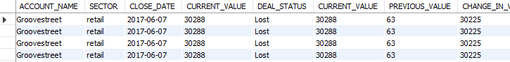

Analysis: These accounts reflect mixed performance and are not fully disengaged instead they show purchase value growth

**Q: HOW DO INDIVIDUAL SALES MANAGERS PERFORM IN TERMS OF OVERALL DEAL OUTCOMES, AND WHICH SALES AGENTS UNDER THEM ARE THE MOST EFFECTIVE BASED ON WIN RATE AND TOTAL DEAL VALUE.**

**GOAL: TO PROVIDE LEADERSHIP WITH A COMPREHENSIVE PERFORMANCE SUMMARY OF EACH SALES MANAGER FOCUSING ON AVERAGE DEAL VALUE FROM WON DEALS, WIN RATE PER SALES AGENT, IDENTIFYING THE TOP PERFORMING AGENT PER MANAGER BASED TOTAL DEAL VALUE FROM CLOSED WON DEALS.**

WITH AGENT_STATS AS

(SELECT ST.MANAGER,SP.SALES_AGENT, COUNT(SP.DEAL_STAGE) AS TOTAL_DEALS,

SUM(SP.CLOSE_VALUE) AS TOTAL_VALUE,

SUM(CASE WHEN DEAL_STAGE = 'WON' THEN 1 ELSE 0 END) AS TOTAL_WON_DEAL,

AVG(CASE WHEN DEAL_STAGE = 'WON' THEN CLOSE_VALUE ELSE NULL END) AS AVG_WON_VALUE

FROM SALES_PIPELINE SP

INNER JOIN SALES_TEAM ST ON SP.SALES_AGENT = ST.SALES_AGENT

GROUP BY ST.MANAGER, SP.SALES_AGENT),

AGENT_RANK AS

(SELECT *,

RANK() OVER(PARTITION BY MANAGER ORDER BY TOTAL_VALUE) AS AGENT_RANK, TOTAL_WON_DEAL/TOTAL_DEALS

AS WIN_RATE

FROM AGENT_STATS)

SELECT MANAGER, SALES_AGENT, TOTAL_VALUE, AVG_WON_VALUE, TOTAL_WON_DEAL,

WIN_RATE, AGENT_RANK

FROM AGENT_RANK

WHERE AGENT_RANK = 1 OR WIN_RATE > .7

ORDER BY TOTAL_VALUE, TOTAL_WON_DEAL, WIN_RATE;

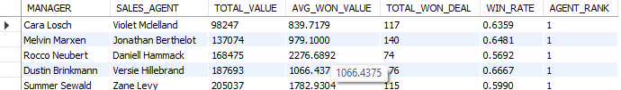

Analysis: By aggregating metrics like avg won value, win rate and total won deal, this report

identifies managers like cara,melvin consistently delivered high value deals and sales agent like

Rosalina outperformed others within the same team,the rank() logic pinpoints top agents per manager surfacing high potential talent, filtering for agents or filtering win rate > 70% captures top strong performers who might not be top in raw value but show high efficiency in conversions.

**QUESTION: HOW DO DIFFERENT PRODUCT SERIES PERFORM ACROSS SECTORS IN TERMS OF REVENUE, ACCOUNT ADOPTION AND STRATEGIC ACCOUNT WINS?**

**-- FOR EACH PRODUCT SERIES GENERATE A REPORT THAT SHOWS TOTAL REVENUE GENERATED PER SECTOR FROM WON DEALS ONLY NO OF UNIQUE ACCOUNTS THAT PURCHASED FROM EACH SERIES PER SECTOR THE TOP ACCOUNT(TOTAL CLOSE VALUE) IN EACH SECTOR FOR THAT PRODUCT SERIES**

**GOAL: TO GUIDE PRODUCT STRATEGY AND CROSS FUNCTIONAL ALIGNMENT BETWEEN SALES AND PRODUCT TEAMS BY:**

* MEASURING TOTAL REVENUE PER PRODUCT SERIES PER SECTOR.
* BY COUNTING HOW MANY UNIQUE ACCOUNTS BOUGHT EACH PRODUCT SERIES IN EACH SECTOR, WE CAN SEE HOW WIDELY ADOPTED A PRODUCT IS ACROSS INDUSTRIES.
* HIGHLY TOP REVENUE GENERATING ACCOUNTS PER SECTOR-PRODUCT COMBINATION.
* THIS GIVES CLARITY ON WHERE EACH PRODUCT PERFORMS BEST AND CROSS SELLING OR UPSELLING MAYBE UNDER LEVERAGED.
* AGGREGATE REVENUE PER ACCOUNT PER SERIES AND SECTOR

WITH SECTOR_REVENUE AS

(SELECT P.SERIES, SP.ACCOUNT_NAME,SUM(SP.CLOSE_VALUE) AS TOTAL_REVENUE,A.SECTOR

FROM SALES_PIPELINE SP

INNER JOIN PRODUCTS P ON SP.PRODUCT = P.PRODUCT

INNER JOIN ACCOUNTS A ON SP.ACCOUNT_NAME = A.ACCOUNT_NAME

WHERE DEAL_STAGE = 'WON'

GROUP BY P.SERIES, SP.ACCOUNT_NAME, A.SECTOR

),

SECTOR_SUMMARY AS

(SELECT SERIES,SECTOR,SUM(TOTAL_REVENUE) AS TOTAL_SECTOR_REVENUE,COUNT(DISTINCT ACCOUNT_NAME) AS UNIQUE_ACCOUNTS

FROM SECTOR_REVENUE GROUP BY SERIES, SECTOR),

TOP_ACCOUNT_PER_SECTOR_SERIES AS

(SELECT SERIES,SECTOR,ACCOUNT_NAME,TOTAL_REVENUE,

RANK() OVER (PARTITION BY SERIES, SECTOR ORDER BY TOTAL_REVENUE DESC) AS SECTOR_RANK

FROM SECTOR_REVENUE

)

SELECT SS.SERIES,SS.SECTOR,SS.TOTAL_SECTOR_REVENUE,SS.UNIQUE_ACCOUNTS,

TP.ACCOUNT_NAME AS TOP_ACCOUNT,

TP.TOTAL_REVENUE AS TOP_ACCOUNT_VALUE

FROM SECTOR_SUMMARY SS

INNER JOIN TOP_ACCOUNT_PER_SECTOR_SERIES TP

ON SS.SERIES = TP.SERIES

AND SS.SECTOR = TO.SECTOR

WHERE TP.SECTOR_RANK = 1

ORDER BY SERIES, TOTAL_SECTOR_REVENUE DESC;

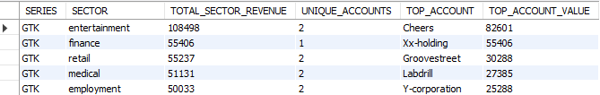

Analysis: By calculating total revenue only from won deals per product series across sectors shows where each product is generating real sales impact and which sectors are revenue rich for specific series. For example,retail is the top revenue generating sector for gtx series while entertainment is the top revenue generating sector for **GTK**. This breakdown by series and sector gives a complete view of revenue concentration and adoption diversity. it identifies top accounts like y-corp and cheers per sector & series, it uncovers which clients are the most valuable helping in prioritizing retention, custom offers or case studies.if product series like **GTK** is generating 65% of its revenue from entertainment sector, it is a clear to double down on sector specific campaigns.